County Councillor Report – Alvechurch Parish Council

It has been a difficult few months at County Hall with the passing of my colleague and friend Cabinet Member for Children & Families, Cllr Andy Roberts. Andy had been a Councillor for over 20 years and devoted his life to one of service for his community and neighbours. It is a big loss for the council, and I pay tribute to him for his work. It is testament to Andy’s commitment, that Worcestershire Children’s First has just been rated Good by Ofsted after some turbulent times. The Leader of the Council has now appointed Cllr Steve Mackay as the new Cabinet Member for Children & Families, and I wish him all the best in this new role and look forward to working with him.

I wanted to update you on some concerning news locally in that Raac concrete has been discovered in County Hall and as a result sections of the building have been closed off, including key democratic services and members facilities. We have however been assured that the functions of the Council will continue as usual, and that any remedial works will be appropriately budgeted without any changes to existing funds or commitments. It is clear that the extent and scale of Raac presence in public buildings across the UK and locally has not yet been discovered and as investigations continue, I hope that central funding becomes available to support these critical buildings and infrastructure.

In a similarly concerning vein, is the issuing of a section 114 notice by Birmingham City Council. Although we fortunately do not come under Birmingham City Council, the knock-on effect on public transport and other shared services could be substantial. Officers at WCC are taking urgent steps to assess any impacts and mitigate their effect. It is a stark reminder of the pressures faced by local government with ever increasing demand and prices. It is however pleasing to see and receive assurance that WCC is in a financially secure and sustainable position following years of careful fiscal management.

I also have some specific local items that I wanted to update the council on, and these are as follows:

Alvechurch Village
- Red Lion Street Railings – The new railings to replace the damaged ones have now arrived and should be installed within the next few weeks. As usual we had the delay in ordering the specifically ornate ones that are used in the conservation area. I have asked WCC to stock a few sets of each now going forward so that in the event of further damage, they can be replaced more swiftly.
- Disabled Bays – I have been consulting the Chairman in relation to the decision making on the disabled bays in the square. It is my understanding is that the desire of APC to have the two converted into one “proper” one is so that it is clearly marked, but importantly can be enforceable. After investigations by the legal team at WCC, they are clear that the TRO makes both bays fully enforceable in their current form. Ticket officers should be taking steps to enforce and have all the legal powers to do so. I have therefore provisionally agreed that as an initial step, we should repaint the two bays with clearer markings, including new writing and disabled symbols being painted. Likewise, the intention is to install two signs directly at the end of each bay making clear it is blue badge holders only. After this work, there should be no excuse for enforcement action not to be taken.
- Data cable information – this has now been passed to APC and I have had confirmation of receipt from the clerk.
- Station Car Park – I am aware of a number of residents and councillors requesting information as to the improvement works planned for the car park. These are currently in a commercially sensitive stage and so information is currently confidential. I would hope to be able to share more information by my next report and I will as always stated ensure a representative of APC is involved in the final stages.

Hopwood
- Pedestrian Refuge – I am still waiting to hear from the team on when this can be programmed. My understanding is that they may now also be able to facilitate one in Bordesley and so they would aim to install both at the same time.
- Road Sweeping and Gullies – I have been informed that the gullies in Hopwood are full again. The most efficient way of getting this resolved is using WCC’s Report It site and selecting the specific gully which needs emptying, as this will go straight to the clearance team. I can then chase up using the reference number, if necessary, but all requests are usually actioned within 28 days.
- Hopwood Mohican – This has now been cut down. I have asked for WCC to note this for forthcoming years so that we don’t have to request this every time.
- Ash Lane – I am pleased to have decided to put some money into improving the junction turning into Ash Lane. This will include a complete resurface of the raised island, including slight adjustment to the angling to force cars further round to the left, new illuminated bollards (including no right turn), new signage both on the approach and directly at the junction and also all new lining and hashing.

Rowney Green & Weatheroak
- I recently arranged for the Chairman of APC to meet with my highways officer and representatives of the RGA. This discussion was very productive and as a result, I have approved and funded some new works including:
  - a new speed data survey to assess the extent of any speeding issue;
  - a new gully improvement scheme, including the raising of a number of gullies to prevent pooling and the instillation of protective barriers and a spillway outside of the dell to combat localised flooding; and
  - improved signage and tree/shrubbery pruning along The Holloway to warn road users of narrowing.
- The details of the scheme will be finalised over the coming weeks and I shall share this with the RGA and APC in the usual way.
- I look forward to the upcoming meeting with Weatheroak residents and APC to discuss possible investment.

Bordesley
- It is good to see us over the major hurdle of works and I am hopeful things should begin to improve. I know in the immediate vicinity I have requested some works outside number 433 for replacement kerbing – this has been delayed for over a year now and the resident has been waiting very patiently.
- I know the road surface is currently very patchy and it is good that WCC have agreed to completely resurface the road. However, they will not do this until the work at the junction have been completed as it would be waste to lay a new surface that would likely be cut into by these works.

As always, I have various other individual casework matters ongoing. If anyone would like support, they can always email me on aluckman@worcestershire.gov.uk and I will be happy to help.

Best wishes

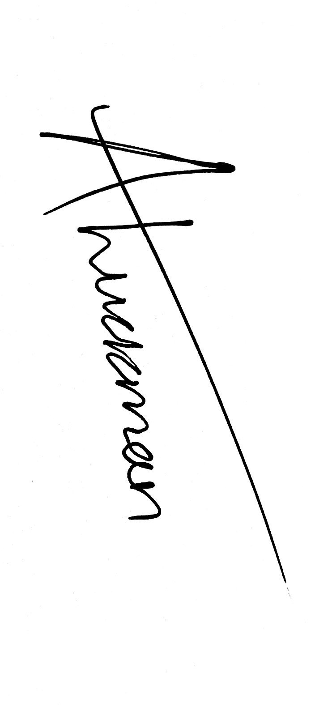

Cllr Aled Luckman
County Councillor for Alvechurch Division

